Accessories

Comprehensive range of operating table accessories

This comprehensive selection of accessories is designed to complement Merivaara operating tables in a variety of surgical procedures. Operating table accessories represented in this brochure are manufactured or distributed by Merivaara. When equipped with these high-quality accessories the tables are also suitable for many specialized procedures. The safe and easy fixing and ergonomic design ensure a smooth surgical process with less time demands. All materials used have been carefully selected. The soft, body conforming surfaces provide comfort and safety for the patient, as well as meeting surgical requirements.
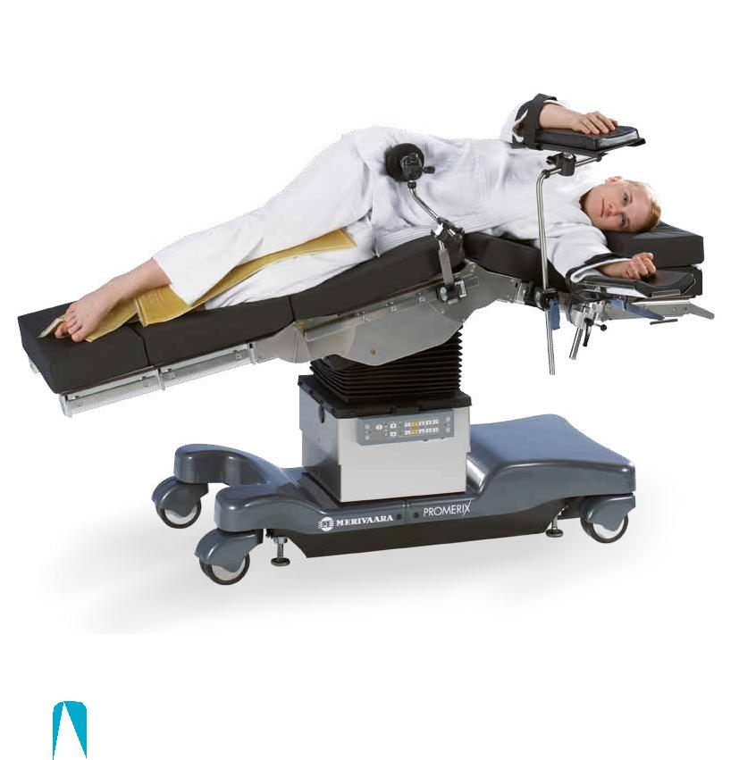

2

Contents

Arm rests �������������������������������������������������������������������������������������������������������������������������������������������������������4 Arm and hand tables ���������������������������������������������������������������������������������������������������������������������4 Supports and straps �������������������������������������������������������������������������������������������������������������������������5 Head rests �����������������������������������������������������������������������������������������������������������������������������������������������������6 Leg rests ���������������������������������������������������������������������������������������������������������������������������������������������������������7 Leg sections �����������������������������������������������������������������������������������������������������������������������������������������������7 Leg holders and supports ���������������������������������������������������������������������������������������������������������8 Rail extensions ���������������������������������������������������������������������������������������������������������������������������������������9 Anesthesia screens and infusion rod �������������������������������������������������������������������������9 Clamps ���������������������������������������������������������������������������������������������������������������������������������������������������������10 Bowls ���������������������������������������������������������������������������������������������������������������������������������������������������������������10 Control devices ���������������������������������������������������������������������������������������������������������������������������������11 Table top sections ���������������������������������������������������������������������������������������������������������������������������11 Carbon fibre sections �����������������������������������������������������������������������������������������������������������������11 Table top sections for Promerix �������������������������������������������������������������������������������������12 Table top sections for Practico ���������������������������������������������������������������������������������������12 Pads �������������������������������������������������������������������������������������������������������������������������������������������������������������������14 Other accessories ���������������������������������������������������������������������������������������������������������������������������15 Special devices �����������������������������������������������������������������������������������������������������������������������������������15 Orthopedic extension device �����������������������������������������������������������������������������������������16

Recommended accessories for

the most common fields of surgery. �����������������������������������������������������������������������18

3

Accessories

Arm rests

Arm and hand tables

1.
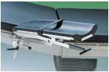
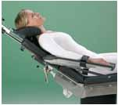

2.
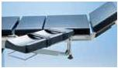

3.
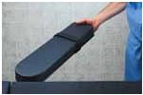

4.
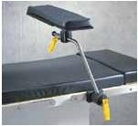

5.
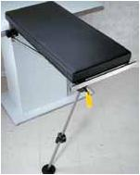

6.
1. Arm rest 19180
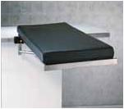
Padded arm rest, incl. clamp and strap. Adjustable height and angle (ball joint), easy to operate and adjust by one lever.

Order no. 1000 19180

1000 19180U for US-rail

Suitable rails: EUR, US

7.

2. Arm rest with radial clamp and ball joint 19185

Padded arm rest, incl. clamp and strap. Adjustable height and angle (ball joint), easy to operate and adjust by one lever. Fixing to rail with radial clamp to give wider adjustment angles. Incl. radial clamp and strap 110.

Order no. 1000 19185
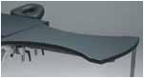
1000 19185U for US-rail

Suitable rails: EUR, US

3. Arm rest 125 | 8.

Padded, includes a fixing clamp and straps 110. Adjustable height. Gas spring assisted angle adjustment.
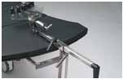
Order no. 1000 00125

Suitable rails: EUR, US

8.

4. Easy armboard 11801

Easy to install to the siderail. Spring loaded design simply snaps onto the rail and is released by a convenient lever accessible from both sides. Light weight armboard rotates 180°. Fully radiolucent with comfortable pad and velcro strap.
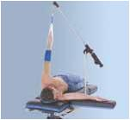
Order no. 1000 11801(EUR) 1000 11801B (UK)

Suitable rails: EUR, UK

5. Lateral armboard 11802

Provides arm support for prone, neuro, lateral and chair positions. A lockable ball joint combined with 150 mm of horizontal travel permits a wide range of position flexibility. The premium durasoft pad ensures patient comfort. Universal clamp 10300 is needed for fixing.
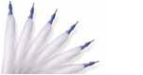
Order no. 1000 11802 | Lateral arm board | 9.
1000 10300 | Universal clamp

Suitable rails: EUR, US, UK
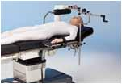
6. Arm and hand table 11911
Radiolucent top (350 × 800 mm), light to
handle. Swivel-ball leg slides, angles and
folds provide unimpeded access. Adjust
vertically for tables with X–ray tops. | 10.
Endrail provided for traction attachment.
Mounts to siderail with two included
clamps 11043 (EUR/UK), For US-rail
2 pcs clamps needs to be ordered
separately. Soft, premium pressure
management pad improves patient
comfort and stability. | 10.
Order no. 1000 11911 Arm table
1000 11043 U Clamp for US-rail
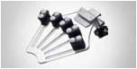
Suitable rails: EUR, US, UK

7. Carpa table 11912

A reduced-size (350 × 650 mm) arm and hand table for carpal tunnel and other minor procedures. Light weight, 2.7 kg. Unique cantilevered side frames create an extremely rigid surface that is completely radiolucent. Vertically adjustable 50 mm. Soft pressure management pad for optimum patient comfort and stability. Mounts to siderail with two included clamps, 11043 (EUR/UK). For US rail 2 pcs clamps needs to be ordered separately.

Order no. 1000 11912 Carpa table

1000 11043U Clamp for US-rail

Suitable rails: EUR, US, UK

8. Arm operating table 10390

Special shaped arm operating table with one support leg. Option to use arm traction device 10392 and hand fixation device 10393 (“Weinberger – type”). Includes mattress and clamps.

Order no. 1000 10390 Hand operating table 10390

1000 10392 Traction device
10392 for 10390 only

1000 10393 Handfixation device 10393 for 10390 only

1000 10390U Hand operating table 10390U for US-rail

Suitable rails: EUR, US

9. The Weightless Shoulder Suspension System 64436

Includes one sterile Arm Trap Disposable Sterile Arm Trap1000 21200 for shoulder suspension system, arm trap is affixed to patient with CoFlex® NL Self-Adherent Wrap (roll included). Incl. 6 pcs. Clamp 10300 is required for fixing.

Order no. 1000 64436 Weightless shoulder suspension system

1000 10300 Universal clamp

1000 21200 Disposable Sterile Arm Trap

Suitable rails: EUR, US, UK

10. Humerus traction device

Traction device 11443 for intramedullary nailing of the humerus, (requires clamp 10300). Padded counteraction post for humerus, (requires clamp 10300).

Weinberger hand traction device, for hand and finger traction.

Order no. 1000 11443 Traction device 11443 1000 11438 Counteraction post 1000 10300 Clamp 10300

1000 10393 Weinberger hand traction device

Suitable rails: EUR, US, UK

4

Supports and straps

11. Wrist straps (pair) 107
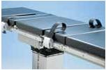
Fixed to the accessory rail with clamps. Safety belt type.

Order no. 1000 00107

Suitable rails: EUR

11.

12. Leg / Body strap 10886, wide
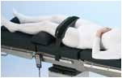
Fixing with velcro-tape. Order no. 1000 10886

Suitable rails: EUR, US, UK

12.
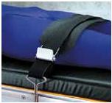

16. Supporting Roll, vertical
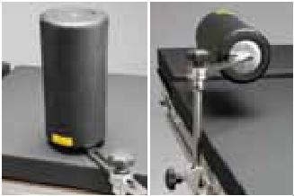
Order no. 1000 10368 (requires clamp 10301)

Suitable rails: EUR

  - Supporting Roll, horizontal

- 17. Order no. 1000 10369 (requires clamp

10301)

Suitable rails: EUR

 | 18. Shoulder supports 19129
 | (pair)
 | Includes clamps. Padded. Adjustable
 | angle and distance to shoulders.
 | Order no. 1000 19129
18. | Suitable rails: EUR
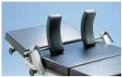

13.
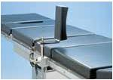
13. Patient restraint strap 11081

Attaches to the siderail quickly with stainless steel hooks. Adjust easily with two airplane-style buckles. The strap is made of strong, conductive,

reinforced rubber for durability and ease of cleaning.

Order no. 1000 11081

Suitable rails: EUR, US, UK

14. Side support 120

Includes a clamp and PU-pad. Adjustable height, angle and distance to patient.

Order no. 1000 00120

Suitable rails: EUR

 | 19. Shoulder braces 11295 (pair)
 | Provides comfortable support for
 | Trendelenburg positioning. The durasoft
 | pads on broad support surfaces tilt as
 | needed to conform to bony shoulder
19. | prominences and minimize pressure.
 | For fixing Rail clamp 11043 is needed,
 | 2 pcs. (not included).
 | Order no. 1000 11295
 | Suitable rails: EUR (11043), US (11043U)
 | UK (11043)
 | 20. Straps for armrest 110 (pair)
 | Straps for 110 for arm rests 125, 19180
 | and 19185.
 | Order no. 1000 00110
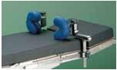
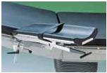
14.

15. Lateral braces 11651 and 11652
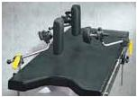
11651 with round pad, 11652 with rectangular pad. Provide secure and comfortable positioning for hip and other procedures requiring optimum lateral stability. The durasoft pads provide soft

15. cushioning of bony prominences. The swivelling heads conform to anatomical contours, can be securely locked for precise positioning. Includes mounting clamps 11043. For US-rail 2 pcs clamps needs to be ordered seperately.

Order no. 1000 11651 Lateral brace, round pad

1000 11652 Lateral brace, rectangular pad

1000 11043 U Clamp for US-rail

Suitable rails: EUR, US, UK

20.

21. Support belt
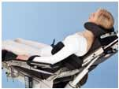
Support belt for Beach Chair.

Order no. 1000 20127

Incl. a clamp, 1 pcs

Suitable rails: EUR, US, UK

21.

22. Leg- / arm protector 60485
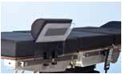
Padded leg- / arm shield for safe patient

positioning.

Order no. 1000 60485

22.

5

Accessories

Head rests
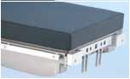

23.

23. Fixing adapter 60146
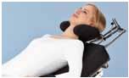
For Doro/Mayfield® Cranial Positioning System and other special head rests. For Promerix, Practico.

Order no. 1000 60146

Suitable with: Promerix, Practico | 30.

30. Special head rest 30126

For “Beach Chair” back rest for shoulder and upper arm procedures. Unique sliding­ function with double joint mecha-nism, very wide adjustments

in all ­directions.

Fits to Promerix 60525 and Practico 30125 back rests.

Order no. 1000 30126.

 | 24. Wide headrest 141
 | Size 270 × 400 mm. Fits all Merivaara
 | operating tables. For Promerix and
 | Practico the fixing adapter is needed.
 | Order no. 1000 00141
24. | Suitable with: Promerix, Practico, Rapido,
 | OP1650
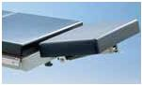
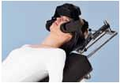
 | 25. Narrow headrest 142 | 31.
 | Size 200 × 270 mm. Fits all Merivaara
 | operating tables. For Promerix and
 | Practico the fixing adapter is needed.
 | Order no. 1000 00142
25. | Suitable with: Promerix, Practico, Rapido,
 | OP1650
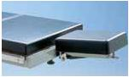
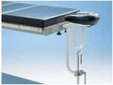

 | 26. Head rest 18101 (wide)
 | With Rapido for general surgery, all
 | Merivaara operating tables with “Beach
 | Chair”- back rest. For Promerix and
 | Practico the fixing adapter is needed.
26. | Order no. 1000 18101. | 32.
 | Suitable with: Promerix, Practico, Rapido,
 | OP1650
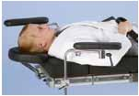
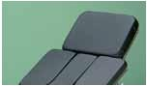

 | 27. Special head rest 18143
 | For ENT-surgery. Fits all Merivaara
 | operating tables. For Promerix and
 | Practico the fixing adapter is needed.
 | Order no. 1000 18143 | 33.
27. | Suitable with: Promerix, Practico, Rapido,
 | OP1650/1700
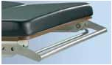
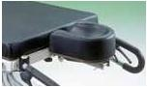

 | 28. Special head rest 18150 for
 | ophthalmology & ENT
 | For ophthalmology and ENT-surgery. Fits
 | to all Merivaara operating tables.
 | For Promerix and Practico the fixing
28. | adapter is needed.
 | Order no. 1000 18150
 | Suitable with: Promerix, Practico, Rapido,
 | OP1650/1700
 | 29. Special head rest 18151 for | 35.
 | ophthalmology
 | For Ophthalmology, double joint
 | mechanism, wider range of adjustments.
 | For Promerix and Practico the fixing
29. | adapter is needed.
 | Order no. 1000 18151
 | Suitable with: Promerix, Practico, Rapido,
 | OP1650/1700 | 36.
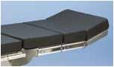
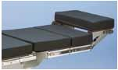
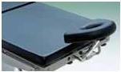
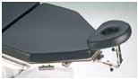
Suitable with: Promerix, Practico, with Beach chair back rests

31. Helmet type head rest 30128

Helmet type head rest 30128 for shoulder and upper arm procedures with”Beach Chair” back rest.

Unique sliding function with double joint mechanism, very wide adjustments in all directions. Fits Promerix 60525 and Practico 30125 back rests.

Order no. 1000 30128

Suitable with: Promerix, Practico, with Beach chair back rests

32. Neurosurgical head rest 144

Padded. Fits all Merivaara operating tables. For Promerix and Practico the fixing adapter is needed.

Order no. 1000 00144

Suitable with: Promerix, Practico, Rapido, OP1650

33. Arm supports 151 (pair)

Fixing to the accessory rails. Includes clamps.

Order no. 1000 00151

Suitable rails: EUR, UK, US

34. Push bar to the head end of Promerix and Practico 20593

Suitable for 60140 and 60142 Head rests.

Order no. 1000 20593

Suitable with: Promerix, Practico

35. Gas spring assisted head rest 60140

Optional mattresses moulded IS or visco elastic VEF. Accessory rail option EUR or US.

Order no. 1000 60140

Suitable with: Promerix, Practico

36. Double articulation head rest 60142

Gas spring assisted. Optional mattresses moulded IS or visco elastic VEF. Including accessory rails (EUR, US).

Order no. 1000 60142

Suitable with: Promerix, Practico

6

Leg rests
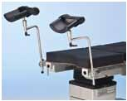

37.

37. Leg rests 20118 (pair)

Padded and with velcro straps and a ball joint. Stainless steel. Universal clamp 10300 needed for fixing.

Order no. 1000 20118

10300 for all rails
Leg sections

 | 42. Divided leg section
 | Section replaces one-piece foot section.
 | Gas spring assisted.
 | Order no. 1000 00148 OP 1650
 | 1000 18261 Rapido
 | 1000 30248 Practico, Promerix
42. | Suitable with: Rapido, Practico, Promerix,
 | OP1650
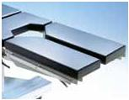

38.
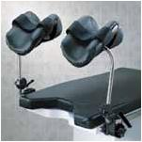
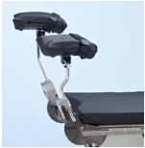

39.

38. Powered Leg rests 60482
(pair) for Promerix table’s pow-
ered leg joint
Provides excellent patient comfort and
precise surgical positioning.
The VEF-pad reduces popliteal pressure.
Velcro straps for security.
Integrated clamps included. | 43.
Order no. 1000 60482
Suitable with: Promerix
39. Knee crutches 11181 (pair)
Provides excellent patient comfort and
precise surgical positioning.
The “Doughy soft” pad reduces popliteal
pressure. Velcro straps for security.
Universal clamp 10300 is needed for
fixing. | 44.
Order no. 1000 11181
10300 for all rails
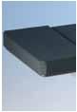
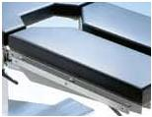

43. Accessory rails for divided leg sections

Optional rail for Rapido/ 1650 divided leg sections.

Order no. 1000 01481 1650/Rapido, for EUR-rail

1000 01482 Rapido, UK-rail

1000 01483 Rapido, US-rail

Suitable with: Rapido, OP1650

44. Foot rest/table extension
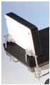
20114

Suitable for all Merivaara tables. Available both IS and VEF mattress, or without the mattress. Universal clamps (2 pcs) included.

Order no. 1000 20114

Suitable with: all Merivaara tables

40.
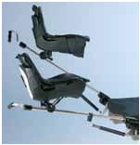
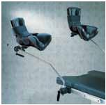

41.

40. Stirrup system 12581 (pair)

Eliminates pressure of the popliteal fossa and perineal nerve. Eliminates uncomfortable rotation, stretching and compression of the knee and hip joints. Universal clamp 10300 is needed

for fixing.

Order no. 1000 12581

10300 for all rails

41. Gas spring assisted, stirrups

12583 (pair)

Allows direct placement with siderail clamps and light weight molded boots which are lined with a durable, soft pad for optimum patient comfort and protection­. Each stirrup joint has lithotomy degree indicators. Clamps 11043 are needed for fixing.

Order no. 1000 12583 Stirrups, pair 1000 11043 Clamps, 2 pcs.
1000 11043 U Clamps for US-rail, 2 pcs.

Suitable rails: EUR (11043), US (11043U), UK (11043)

7

Accessories

Leg holders and supports

 | 45. Leg holder 12551 (pair)
 | Stainless steel construction for smoother
 | operation and improved reliability.
 | Strong rotation lock prevents slippage
 | and permits vertical adjustment from
 | 700 – 1030 mm. Universal clamp 10300 is
 | needed for fixing.
 | Order no. 1000 12551
 | Suitable rails: EUR, UK ,US
45. | 50.
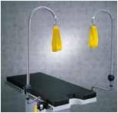
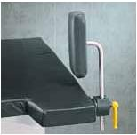

46. Thigh holder 12012
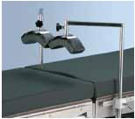
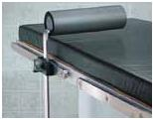
Rotating, complete with antistatic pad. Universal clamp 10200 is needed

for fixing.

Order no. 1000 12012 (incl. 1 pc)

10200 for all rails

51.

 | 47. The prepper 12552
 | The padded cradle comfortably supports
 | patients leg during prep procedure. Shaft
 | can be rotated to move offset in various
 | positions for convenient access to the
 | leg. Generous 750 mm long, 16 mm
 | post. Universal clamp 10300 is needed
 | for fixing.
 | Order no. 1000 12552
 | 52.
47. | 10300 for all rails
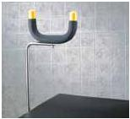
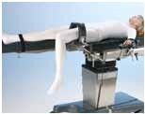

 | 48. Light foot rest
 | Provides a light-weight, easy-to-use foot
 | rest, that supports patient’s legs prior to
 | gynaecological or urological procedures
 | (transport, anaesthesia).
 | Order no. 1000 18001 for Rapido,
 | 1000 20201 for Practico and
48. | Promerix
 | 1000 12001 for OP1650
 | Suitable with: Promerix, Practico, Rapido,
 | OP1650
 | 49. Light foot rest
 | Provides a light-weight, easy-to-use
 | foot rest with latch locking mechanism.
 | Supports patient’s legs prior to
 | gynaecological or urological procedures
 | (transport, anaesthesia).
 | Order no. 1000 60201
49. | Suitable with: Promerix, Practico
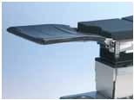
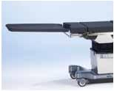

50. Arthroscopic stress post

12530

A levering fulcrum for improved access to the medical compartment of the knee. Mounts to accessory rail. Universal clamp 10300 is needed for fixing.

Order no. 1000 12530

10300 for all rails

51. Total knee stabilizer 12585

Convenient, stable device to support the flexed leg during total knee procedures. Includes pad and clamp 11043 (EUR/UK) For US-rail clamp needs to be ordered separately. Extra pads 12586 are available.

Order no. 1000 12585 Total knee stabilizer 1000 12586 Pads, extra pieces 1000 11043U Clamp for US-rail

Suitable rails: EUR, UK, US

52. Arthroscopic Leg holder 10353

Needs clamp 1000 10308 for fixing. Order no. 1000 10353

1000 10308 Clamp

Suitable rails: EUR, US, UK

8

Rail extensions

 | 53. Accessory rail extension
 | 19128
 | Stainless steel, length 550 mm. Fits
 | to both sides of the table. Suitable
 | for all Merivaara operating tables with
 | European standard siderails.
53. | Order no. 1000 | 19128
 | 1000 | 19128U
 | Suitable rails: EUR (19128), US (19129U)
 | 54. Accessory rail extension
 | 10355
 | Length 400 mm
 | Order no. 1000 | 10355
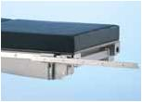
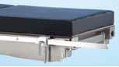
54. Suitable rails: EUR (19128), US (19129U)

55. Accessory extension rail, angeled 10356
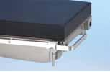
Angeled, Length 270/150 mm Order no. 1000 10356

Suitable rails: EUR (19128), US (19129U)

55.

56. Angular accessory rail 10359
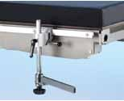
Length 250 mm Order no. 1000 10359

Suitable rails: EUR (19128), US (19129U)

56.
Anesthesia screens and infusion rod

 | 57. Anaesthesia screen 111
 | Adjustable height and angle. Made of
 | stainless steel. Universal clamp 10300 is
 | needed for fixing.
 | Order no. 1000 00111
 | Extension arm 116 (single)
57. | An extra wing is attached to the
 | anaesthesia screen 111, one or two pcs.
 | Order no. 1000 00116
 | 10300 for all rails or 10308
 | 58. Flexible anesthesia screen
 | 11001
 | Malleable screen conforms to any shape
 | desired. Universal clamps 10200 (2 pcs)
 | are needed for fixing.
 | Order no. 1000 11001
 | 10200 for all rails
58.
 | 59. Infusion rod 749
 | Chrome plated, fixed to the accessory
 | rail. Includes fixing clamp. Adjustable
 | height, two or four hooks.
 | Order no. 1000 00749
 | Suitable rails: EUR, US, UK
59.
 | 60. Infusion rod holder 18578
 | Fixed to the base casing, storage holder
 | for Rapido, infusion rod with two hooks.
 | Order no. 1000 18578
 | Suitable rails: Rapido
60.
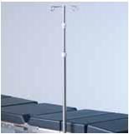
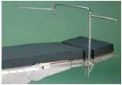
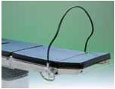
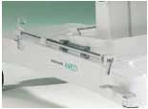

9

Accessories

Clamps |  | Bowls
 | 61. Accessory Clamp 10200
 | Universal Ø 16
 | Accessory Clamp, Universal, ø 16
 | Universal model, fits all railtypes.
 | Aluminium.
 | Catch the ø 16 round pole in vertical or in
 | horizontal direction and Eur-rail size flat
 | bar in horizontal direction. | 66.
61. | Order no. 1000 10200
 | Suitable rails: EUR, US, UK
 | 62. Accessory Clamp 10301 Ø
 | 20 mm
 | Accessory clamp 10301, Ø 20 mm, for
 | EUR-rails.
 | Order no. 1000 10301
 | Suitable rails: EUR
62.
 | 63. Radial Accessory Clamp | 67.
 | 10300 Universal Ø 16-20
 | Radial Accessory Clamp ø16-20,
 | Universal model,fits all railtypes.Stainless
 | steel. Easy to pre-adjust for different
 | diameters ø16-20. Pat. Pend. Extremely
 | good grip to round pole, particularly
 | handy with the leg rests and stirrups with
 | round pole.
 | Order no. 1000 10300
63. | Suitable rails: EUR, US, UK
 | 64. Rail clamp 11043 | 68.
 | Secure locks all accessories with flat
 | mounting posts anywhere along the
 | table siderail. Perfect for table top
 | extensions and knee board applications.
 | Stronger, lighter weight replacements for
64. | original rail locks. Reduces the free play
 | associated with standard clamps.
 | Order no. 1000 11043
 | 1000 11043U
 | Suitable rails: EUR, UK (11043), US (11043U)
 |  | 69.
 | 65. Radial Clamp 10308
 | For round pole, up to Ø 20 mm. Fits to all
 | rails EUR, US, UK (not for leg rests and
 | stirrup systems).
 | Order no. 1000 10308
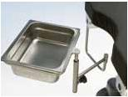
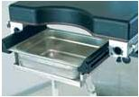
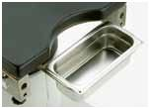
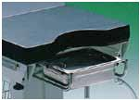
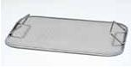
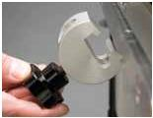
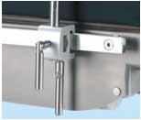
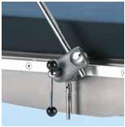
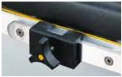
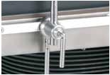
Suitable rails: EUR, US, UK

65. | 70.

66. Bowl 6 l

201571 without drainage, 201572 with drainage. Stainless steel (6 l). Fixed to siderail with a clamp. Fits all Merivaara operating tables.

Order no. 100 201571 or 100 201572

Bowl 6 l, for Promerix, Practico and Rapido without attachment

Bowl without drainage 20501, bowl with drainage 20502

Order no. 1002 01501 1002 01502

Suitable rails: EUR, US

67. Bowl 6 l, for Promerix

61581 without drainage, 61582 with drainage. Stainless steel. Fixed under the table top. Holder for 6l bowl, fixed under the base, Promerix 61580.

Attached to gyn-section 60440 or 60425. Order no. 1000 61580 Holder

1000 61581 Bowl without drainage + holder

1000 61582 Bowl with drainage + holder

Suitable with: Promerix

68. Bowl 6 l, for Rapido

181581 without drainage, 181582 with drainage. Stainless steel. Fixed under the table top.

Order no. 1001 81581 bowl without drainage 1001 81582 bowl with drainage

Suitable with: Rapido

69. Bowl 4 l, for 1650

158 without drainage. Stainless steel. Fixed under the table top.

Order no. 1000 00158

Suitable with: OP1650

70. Screen 18159

Separately for bowls, 6 l. Order no. 1000 18159

Suitable with: Bowls 6 l

10

Control devices Carbon fibre sections

71. Control devices for Promerix
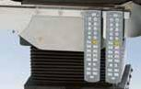
Hand control for Promerix

Order no. 1000 60800 Hand control, wired

71. 1000 60820 IR-hand control

Suitable with: Promerix

72. Merimote
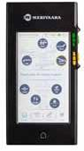
Merimote™ is a multifunctional remote control for Merivaara’s Promerix operating table. With intuitive touch screen Merimote™ guides to get full advantage of the working environment and gives access to more advanced product support.

Order no. A42682400

72.

73. Foot control for Promerix & Practico
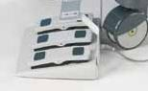
Foot control device Height, Trend., Tilt (optional Back on sliding).

Order no. 1000 60850

73. Suitable with: Promerix, Practico

Table top sections

 | 74. Gynaecologic/urologic
 | extension 18153 for Rapido
 | Gives more space (+150 mm) for the
 | surgeon and makes C-arm use easier.
 | Includes mattress.
 | Order no. 1000 18153
74. | Suitable with Rapido
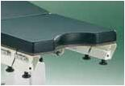

 | 75. Table width extender
 | 10659, 10659U (single)
 | Increases the support surface for large
 | patients. Can be used individually or
 | in multiples to create a custom fit. Size
 | 100 × 500 mm. Fixed to the accessory
 | rail. Includes pad and accessory rail.
 | Order no. 1000 10659 (EUR)
 | 1000 10659U (US)
75. | Suitable with: Promerix, Practico
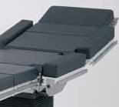

 | 76. Carbon Fibre Back-/Leg Plate
 | 60500
 | Promerix Carbon Fibre section can be
 | used as a back rest or as a leg plate
 | Length 950 mm ( = like 40-section
 | +25-section + head plate), replaces
 | normal Promerix back and/or leg
 | sections. Width 540 / 450 mm. Max.
 | patient weight up to 275 kg. Length
 | of 360-deg. imaging area 650 mm.
 | Mattress for the Carbon Fibre back-/leg
 | plate 60501.80 mm VEF (Visco elastic
76. | foam), antistatic, welded seams.
 | Order no. 1000 60500 Carbon fibre back-/
 | leg plate
 | 1000 60501 mattress for carbon
 | fibre back plate
 | Suitable with: Promerix
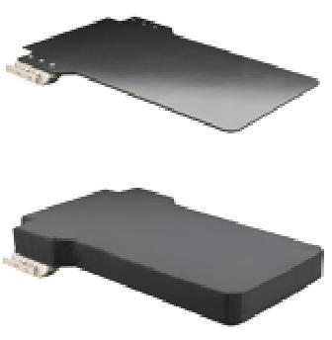

 | 77. Carbon Fibre Arm Rest 60510
 | Specially made to used with the
 | Carbon Fibre back rest. The patient’s
 | counterweight is used to hold this arm
77. | rest on its palace.
 | No metal parts, 100% Carbon Fibre –
 | construction.
 | Total length 900 mm, arm rest size
 | 160 x 680 mm.
 | Order no. 1000 60510
 | Suitable with: all tables
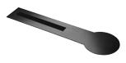

 | 78. Mattress for the Carbon Fibre
 | Arm Rest 60511
 | Pad for the Carbon Fibre Arm Rest 80
 | mm VEF (Visco elastic foam), antistatic,
78. | welded seams. W = 160mm, L = 600 mm.
 | Order no. 1000 60511
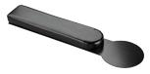

11

Accessories

79. a Table top sections for Promerix

Gas spring assisted leg section, length 645 mm 1000 30147

Gas spring assisted divided leg sections, length 880 mm 1000 60475

Gas spring assisted divided |  | ENT-upper back
leg sections, length 680 mm
 | 40-section | section
1000 30248
 | 1000 60240 | 1000 60325
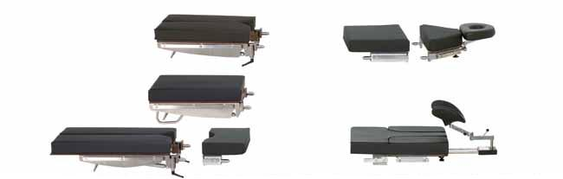
(Head rest 18150)

Beach Chair Back | (Head rest
Rest for shoulder | 1000 30126)
arthroscopy
1000 60525

25-gynaecologic section

1000 60425

Extension 25-section 1000 60250

Powered divided leg sections, dual joint abduction, length 880 mm 1000 60480

25-section | 40-gynaecologic |  | 40-section | 25-section
1000 60250 | section 1000 60440 | Seat section | 1000 60240 | 1000 60250 | Head rest 60140
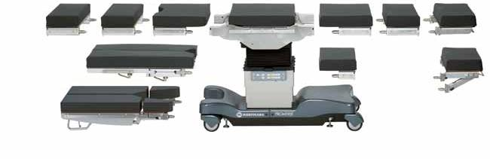

25-short section Head rest

1000 60225 60142

Powered, divided leg sections, 4 section incl. solid pelvic plate, length 865 mm, 1000 60484

79. b Table top sections for Practico
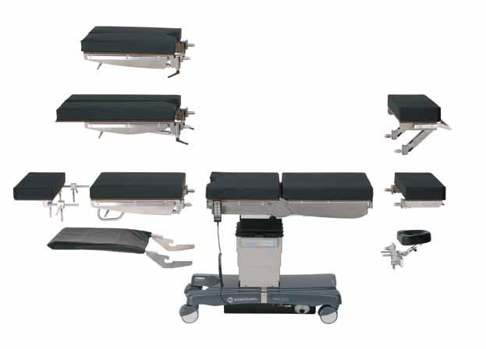

Gas spring assisted divided leg sections, length 680 mm 1000 30248

Gas spring assisted divided leg sections, dual joint abduction, length 880 mm 1000 60475

Table top extension 270 mm 1000 20114

Double articulated head rest 1000 60142

 | Standard seat | Standard el. back
Gas spring assisted leg | section 1000 30020 | rest 1000 30122
section, length 645 mm | Seat section with | Beach Chair back
1000 30147 | sliding 1000 30030 | rest 1000 30125
Head Section 1000 60140

Lightweight foot rest | Adapter for special head rest
1000 20201 | and Doro 1000 60146

12

 | Table top section | Promerix: | Practico: | Mattresses VEF | Mattresses IS
 |  | Section | Section | 80 mm | 65 mm
 |  | code | code
Head rests | Gas spring assisted headrest | 100060140 | 100060140 | 100060951 | 100060901
 | Doubple articulation headrest | 100060142 | 100060142 | 100060951 | 100060901
 | Head Rest for Kidney and Thorax | 100060147 | 100060147 | 100060951 | 100060901
 | position

Back sections

Lower back rest | 25-short section | 100060225 |  | 100060955 | 100060909
 | 40-section | 100060240 |  | 100060956 | 100060908
Upper back rest | 25-section | 100060250 |  | 100060955 | 100060902
 | ENT-upper back section | 100060325 |  | 100060962 | 100060912
 | Beach Chair backrest | 100060525 |  | upper: 1000 60963 | upper: Not avai-
 |  |  |  | set | lable
 |  |  |  | lower: 1000 60955 | lower back: 1000
 |  |  |  |  | 60909
Back sections: Practico | Beach Chair backrest, Practico, |  | 100030125 | upper: 1000 60963 | Not available
 | - factory assembled |  |  | set
 |  |  |  | lower: 1000 60955 | Not available
 | Back rest, electrical, Practico, |  | 100030122 | A4220 9700 | A4228 4100
 | - factory assembled

Leg sections

Upper leg section / Pelvic | 40-section | 100060240 |  | 100060956 | 100060908
support
 | 25-gynaecologic short section | 100060425 |  | 100060959 | 100060907
 | 40-gynaecologic section | 100060440 |  | 100060957 | 100060905
 | Divided leg section, dual joint abduction | 100060480 |  | right: 1000 60961 | right: 1000 60911
 |  |  |  | left:1000 60960 | left:1000 60910
 | Divided leg plates, 4-sectional, incl. solid | 100060484 |  | Pelvic A4232 7400 | Not available
 | pelvic plate
 |  |  |  | Femur A4235 | Not available
 |  |  |  | 0900, pair
 |  |  |  | Legs A4233 0100, | Not available
 |  |  |  | pair
Lower leg section | Divided leg section, gas spring assisted, | 100060475 | 100060475 | 1000 60961 right | 1000 60911 right
 | long
 |  |  |  | 1000 60960 left | 1000 60910 left
 | Divided leg section, gas spring assisted, | 100030248 | 100030248 | Leg L&R | Leg L: A4230 5900
 | short |  |  | A4233010, pair
 |  |  |  |  | Leg R: A4230 5800
 | One piece leg section, gas spring | 100030147 | 100030147 | A4220 9700 | A4228 4100
 | assisted
 | 25-section | 100060250 |  | 100060955 | 100060902
 | Lower leg section, incl. 2x25-section | 100060465 |  | 1000 60955, 2 pcs | 1000 60902, 2 pcs
Seat sections | Seat section without gynaecological |  |  | 100060953 | 100060903
 | cutout
 | Seat section with gynaecological cutout |  |  | 100060954 | 100060904
 | Seat section with gynaecological cutout
Seat + Back section | + back section, for kidney elevator back |  |  | 1000 60952
 | section

Available with moulded IS-mattress or welded visco-elastic memory foam mattress. Rail options: EUR, UK or USA.

80. PROMERIX VEF-mattress options separate/ Long seat-back mattress

- 3. 7.

  - 3. 8.

25-gyn. + seat + 40-section

40-gyn. + seat + 25-short section

Seat with gyn. + 40-section +
- _{2.} 25-section

Long seat + back mattress

12.

13

Accessories

Pads

81. Stratus gel pads and positioners

Closed head ring
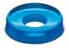
size 140 x 60 x 35mm code 1000 66002

size 200 x 75 x 45mm code 1000 66003
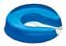

Open head ring

size 140 x 60 x 35mm code 1000 66012

size 200 x 75 x 45mm code 1000 66013
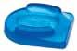

Head pad

size 270 x 230 x 70 mm code 1000 66110

Contoured headrest
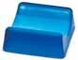
size 190 x 190 x 60 mm code 1000 66081

Prone headrest
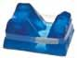
size 280 x 230 x 145 mm code 1000 66111
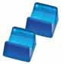

Heel support pads, pair

size 200 x 110 x 70 mm code 1000 66031

Patient positioner
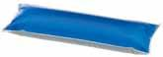
380 x 125 x 63 mm code 1000 66096
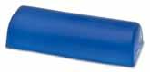

Chest roll with flat bottom surface

405 x 150 x 100 mm code 1000 66042

Armboard pad
600 x 125 x 20 mm code 1000 66072

Crutch stirrup pads, 2 pcs
size 315 x 220 x 10 mm code 1000 66801

Table pads
size 500 x 500 x 10 mm code 1000 66021

size 1170 x 500 x 10 mm code 1000 66022

82. D-pillow 19497, visco-elastic (“memory”) foam
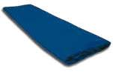
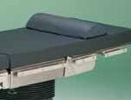
Includes fixing straps, 21 x 49 x 10 cm. Order no. 1000 19497

85.

82.

85. Transfer mattress 19400

Used for transferring a patient between different patient platforms. Easy to use, easy to wipe clean, waterproof material. Colour dark blue.

Size 180 x 55 cm, CE-marked

Order no. 1000 19400

 | 83. Prone Positioning System 60750
60571 | For spine and back procedures in prone position. 4 pcs of pads,
 | including formed head support.
 | Width 540 mm
 | Recommended option + 84. D-pillow 19497
 | Order no. 1000 60750
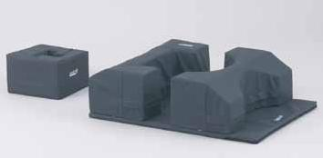
84. Head Pillow for Prone position ­separated 60751

Order no. 1000 60751

83./84.

14

Other accessories

86. Push bars to foot end 18168, pair, foldable
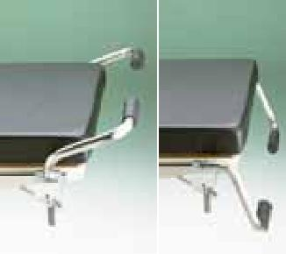
Fits to all tables with EUR-rail in the leg section.

Order no. 1000 18168

Suitable rails: EUR

86.

87. Paper roll holder for Rapido
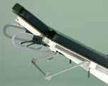
18572

All rail types. Clamps included. Order no. 1000 18572

Suitable rails: EUR, US, UK

87.

88. Side rails 18173/18174
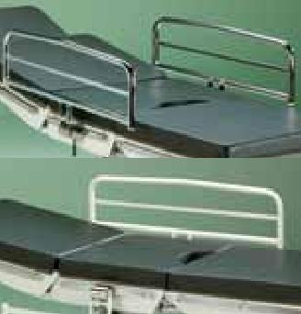
For all tables with EUR rail.

Order no. 1000 18173 chrome plated 1000 18174 epoxy coated

Suitable rails: EUR

88.

89. Wire Basket for utilitys
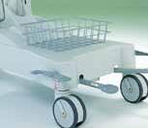
18183

For Rapido.

Order no. 1000 18183

Suitable with: Rapido

89.

90. Oxygen bottle holder 18189
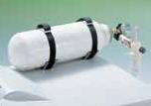
Order no. 1000 18189 for 5l bottle

Suitable with: Rapido

90.

91. Cassette tray
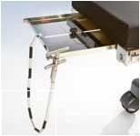
Suitable for different X-ray cassette sizes. Slides on the X-ray cassette rails under the table. Stainless steel.

Order no. 1000 18126 for Rapido 1000 00126 for Promerix,

Practico, OP1650

Suitable with: Promerix, Practico, Rapido,

OP1650

91.

92. Accessory stand 19220
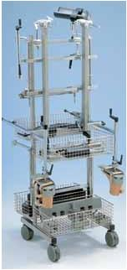
For storing operating table accessories. Stainless steel. Fitted with accessory rails and steel baskets (4 pcs).

Order no. 1000 19220 or 1000 19220U (US rail)

Suitable rails: EUR, UK, US

92.

Special devices

 | 93. Back and kidney elevator
 | 19280
 | To be placed on the table top or on the
 | mattress. The angle is adjustable with
 | a crank mechanism. A separate mattress
 | is included.
 | Order no. 1000 19280
93. | Suitable with: Promerix, Practico, OP1650
 | 94. Proctology accessory
 | 154/30154
 | Allows the surgeon good access to the
 | patient. SWL 180 kg
 | For Promerix 60425 (or 60440) needed.
 | Order no. 1000 30154 Practico & Promerix
 | 1000 00154 OP1650
 | Suitable with: Promerix, Practico, OP1650
94.
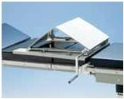
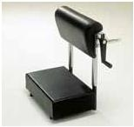

15

Accessories

Special devices

95. The Beach Chair Shoulder System for shoulder arthroscopy
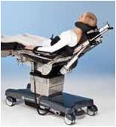
The Beach Chair Shoulder System gives open bilateral access for shoulder and upper arm procedures. Support belt gives extra safety for the patient on the operating side.

60525 replaces Promerix standard back rest. In Practico Beach Chair is an optional electrical back rest (factory

_{95.} assembled). Load capacity up to 275 kg Promerix,225 kg Practico.

Order no.

1000 60525 for Promerix
1000 30125 for Practico (factory assembled)
1000 30126 Head rest for Beach Chair
1000 30128 Helmet type head rest
1000 20127 Support belt for Beach Chair

Suitable with: Promerix, Practico
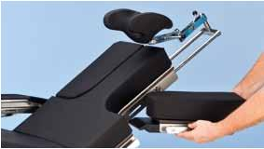

95.

96. Knee -Chest device for spinal procedures 60600
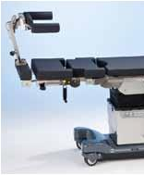
Positioning device with the patient in the knee - chest - position (genucubital position). The entire positioning device

can be brought into the horizontal with the help of the tables motor-driven leg joint and the gas spring assisted knee section. The height of the calf section is adjustable with the help of the crank mechanism, crank can be used from both sides of the table. Support strap, buttocks­ - and side supports are included to the device.

96. | Order no. 1000 60600 Knee chest device

Recommended accessories:
Chest support D-pillow 1000 19497
Prone head rest 1000 66111 or face pillow 1000 60751

Trolley 1000 19285 (see the trolley on page 17)

Suitable with: Promerix
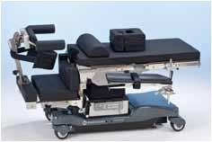

96.

Orthopedic extension device
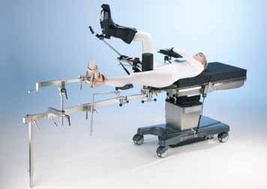

97.

97. Orthopedic extension device 19300

Suitable for treatment of all fractures in

lower extremites. For Promerix, Practico adapter incl., for Promerix gyn. section 60425 or 60440 is needed.

Included in the delivery: Adapter to the table, dual joint extension bars (2 pcs), Support feet (2 pcs), Screw tensioners (2 pcs), Traction boots, adult model (a pair), Pelvic support, perineal post (1pc).

Order no. 1000 19300

98. Short support arm 19313
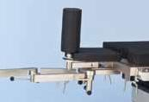
With clamp 19135 for supporting healthy leg with stirrup or leg support, e.g. 20118.

Order no. 1000 19313

- 19313

99. Leg plates 19348
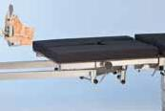
For supporting legs during the anaesthesia before the final positioning.

Order no. 1000 19348

- 19348

100. Accessory stand 19285
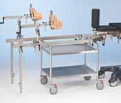
For 19300 and for 60600. Order no. 1000 19285

100.

16

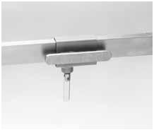

101.

101. Clamp for the extension­ bar with rail

For wide arm 19135 for 19300.

Order no. 1000 19135
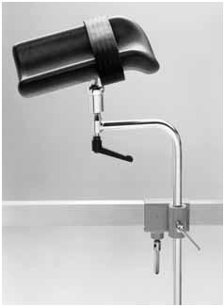

105.

105. Knee crutch 19118 (m. Goepel)

With clamp and velcro-strap, for 19300.

Order no. 1000 19118
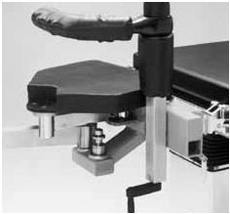

109.

109. Femoral counter traction­ post 19112

For 19300 incl. pads, perineal posts (carbon­ fibre) are radiotranslucent and height adjustable.

Order no. 1000 19112

102.
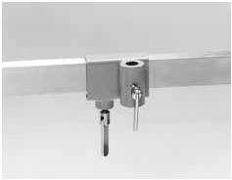
102. Clamp for the extension­ bar 19134

With 19 mm bore for 19300.

Order no. 1000 19134
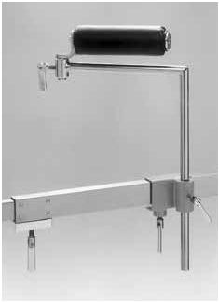

106.

106. Knee support 19124

Radiotranslucent (carbon fibre) and padded with height adjustable support, port and

clamp,attaches to the extension bar, for 19300.

Order no. 1000 19124
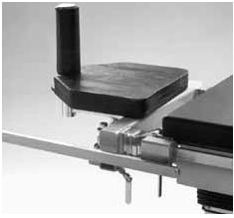

110.

110. Accessory rail elon-gation 19128

With clamp, length 550 mm, for 19300.

Order no. 1000 19128 EUR-rail, UK-rail

1000 19128U US-rail

103.
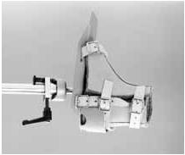
103. Traction boots chil-dren model 19131

Leather boots (pair), bottom plates are attached to the screw tension device with a ball joint

for 19300.

Order no. 1000 19131
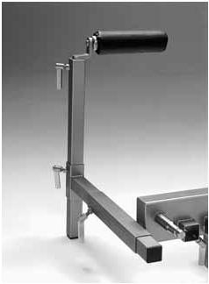

107.

107. Knee support 138

With height adjustable, telescopic support post,

radiotranslucent (carbon fibre) and padded, attaches to the adapter, can be fixed on both sides of the table for 19300.

Order no. 1000 00138
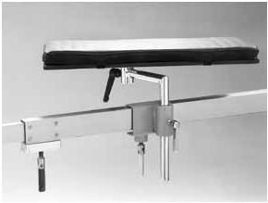

111.

111. Calf support 19126

With clamp and pad, for 19300. Order no. 1000 19126

104.
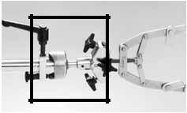

104. Stirrup clamp with rotation 19114

For fixing Kirchner bow (not included in the delivery) traction device. for 19300.

Order no. 1000 19114
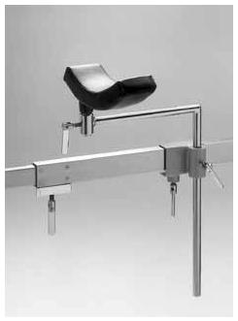

108.

108. Leg rest 19120

Radiotranslucent (carbon fibre) with support post and clamp, attaches to the extension bar, for 19300.

Order no. 1000 19120
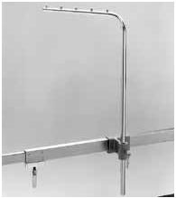

112.

112. Supporting post for plaster cast 19132

For 19300.

Order no. 1000 19132

17

Accessories

Recommended accessories for

the most common fields of surgery

CODE ACCESSORIES : for EUR-rail

ARM RESTS

 |  |  | O | MANUAL
 | MERIX |  |  | O | O
 |  |  |  |  |  | P1650
O
PR |  | PRACTICPRACTIC RAPID O

100000125 | Arm rest 125, with straps 110 | x | x | x | x | x
100019180 | Arm rest 19180, with straps 110 | x | x | x | x | x
100019185 | Arm Rest 19185 w.radial clamp, ball joint | x | x | x | x | x
100011801 | Easy armboard 11801, with straps | x | x | x | x | x
100011802 | Lateral armboard 11802 | x | x | x | x | x
100010300 | - for fixing : 1 pc. Radial Accessory Clamp, Universal 10300 | x | x | x | x | x

SUPPORTS AND STRAPS

100000107 | Wrist straps 107, pair | x | x | x | x | x
100000110 | Straps 110 for arm rests 125 and 19180, 19185 | x | x | x | x | x
100011081 | Patient restraining strap 11081 | x | x | x | x | x
100010886 | Leg / body strap, wide, velcro-type | x | x | x | x | x
100000120 | Side support 120 | x | x | x | x | x
100011651 | Lateral brace 11651with round pad and clamp | x | x | x | x | x
100011652 | Lateral brace 11652 with rectangular pad and clamp | x | x | x | x | x
100019129 | Shoulder supports 19129, pair | x | x | x | x | x
100011295 | Shoulder braces 11295, pair | x | x | x | x | x
100011043 | - for fixing 2x Rail Clamp 11043 | x | x | x | x | x
100020127 | Support belt for Beach Chair | x | x | x
100010368 | Supporting Roll, vertical | x | x | x | x | x
100010301 | - for fixing Accessory Clamp, D20 mm | x | x | x | x | x
100010369 | Supporting Roll, horizontal | x | x | x | x | x
100060485 | Arm- / Leg Shield , incl. pad | x | x | x | x | x

HEAD RESTS

100000141 | Wide head rest 141 | x | x | x | x | x
 | -for Promerix and Practico the fixing adapter is needed 60146
100000142 | Narrow head rest 142 | x | x | x | x | x
 | -for Promerix and Practico the fixing adapter is needed 60146
100000144 | Neurosurgical head section 144 | x | x | x | x | x
 | -for Promerix and Practico the fixing adapter is needed 60146
100018101 | Head section 18101 | x | x | x | x | x
 | -for Promerix and Practico the fixing adapter is needed 60146
100018143 | Special head rest 18143, for ENT-surgery | x | x | x | x | x
 | -for Promerix and Practico the fixing adapter is needed 60146
100018150 | Special head rest 18150, for ENT/ophtalmology | x | x | x | x | x
 | -for Promerix and Practico the fixing adapter is needed 60146
100018151 | Special head rest 18151 for ophtalmology | x | x | x | x | x
 | -for Promerix and Practico the fixing adapter is needed 60146
100000151 | Arm rest 151, pair | x | x | x | x | x
100030126 | Special Head Rest for Beach Chair | x | x | x
100030128 | Helmet type Head Rest for Beach Chair | x | x | x
100333010 | DORO Set 1 | x | x | x
100333020 | DORO Set 2 | x | x | x
100333030 | DORO Set 3 | x | x | x | x | x
100301100 | DORO® Side Rail Adaptor, for OP1700, Practico and Promerix | x | x | x
100060146 | Adapter 60146 for special head rests in Promerix and Practico | x | x | x

FOOT RESTS

100000118 | Leg rests with straps 118, pair |  |  | x | x | x | x | x
100020118 | Leg rests with straps, Goebel-type, pair
100010300 | - for fixing : 2 pc. Radial | Accessory Clamp, Universal | 10300 | x | x | x | x | x
100011181 | Knee crutches 11181, with extra soft pad and straps |  |  | x | x | x | x | x
100010300 | - for fixing : 2 pc. Radial | Accessory Clamp, Universal | 10300 | x | x | x | x | x
100012551 | Leg holders 12551, pair |  |  | x | x | x | x | x
100010300 | - for fixing : 2 pc. Radial | Accessory Clamp, Universal | 10300 | x | x | x | x | x
100012552 | Leg support, "The Prepper" 12552 |  |  | x | x | x | x | x
100010300 | - for fixing : 1 pc. Radial | Accessory Clamp, Universal | 10300 | x | x | x | x | x
100012581 | Stirrup system 12581, with extra soft pad |  |  | x | x | x | x | x
100010300 | - for fixing : 2 pc. Radial | Accessory Clamp, Universal | 10300 | x | x | x | x | x
100012583 | Gas spring assisted stirrups 12583, pair |  |  | x | x | x | x | x
100011043 | - for finxing 2x Rail Clamp 11043 |  |  | x | x | x | x | x
100010353 | Arthroscopic Legholder 10353 |  |  | x | x | x | x | x
100010308 | - for fixing : 1 pcs. Radial Clamp 10308 |  |  | x | x | x | x | x
100012530 | Arthroscopic Stress Post 12530 |  |  | x | x | x | x | x
100010300 | - for fixing : 1 pc. Radial | Accessory Clamp, Universal | 10300 | x | x | x | x | x
100012585 | Total knee stabilizer 12585, incl. Clamp |  |  | x | x | x | x | x
100012586 | Replacement pad 12586 for 12585 |  |  | x | x | x | x | x
100012012 | Thigh Holder (single) |  |  | x | x | x | x | x
100010200 | - for fixing:1 X Accessory Clamp Universal 10200 |  |  | x | x | x | x | x
100012001 | Light foot rest 12001 |  |  |  |  |  |  | x
100018001 | Light foot rest 18001 |  |  |  |  |  | x
100020201 | Light foot rest 20201 |  |  |  | x | x
100060201 | Light foot rest 60201, Promerix |  |  | x | x | x
100060482 | Powered Leg Holders for Promerix |  |  | x

ANESTEHESIA SCREENS AND INFUSION ROD

100000111 | Anaesthesia screen 111 | x | x | x | x | x
100010300 | - for fixing : 1 pc. Radial Accessory Clamp, Universal 10300 | x | x | x | x | x
100000116 | Extension arm 116, for 111 | x | x | x | x | x
100011001 | Anaesthesia screen 11001, flexible | x | x | x | x | x
100010200 | - for fixing:2 X Accessory Clamp Universal 10200 | x | x | x | x | x
100000749 | Infusion rod 749, for EUR-rail, 2 hooks | x | x | x | x | x
100000749 | Infusion rod 749, for EUR-rail, 4 hooks | x | x | x | x | x
100018578 | Infusion rod holder 18578, for Rapido |  |  |  | x

Arm and hand tables

100010390 | Hand operating table 10390 | x | x | x | x | x
100010392 | Traction device 10392 | x | x | x | x | x
100010393 | Handfixation device 10393 | x | x | x | x | x
100011911 | Arm and hand table 11911 | x | x | x | x | x
100011912 | The Carpa table 11912 | x | x | x | x | x

18

 |  |  |  |  |  |  | MANUAL
 | CODE | ACCESSORIES : for EUR-rail |  | MERIX |  | O | O | O
 |  |  |  | O | PRACTICPRACTIC RAPID |  |  |  |  | P1650
 | BOWLS |  |  | PR |  |  |  |  | O
 | 100000158 | Bowl 158, 4 L + attachment, fixed under the base |  |  |  |  |  |  |  | x
 | 100181581 | Bowl 181581, 6 L , fixed under the seat section without drainage |  |  |  |  | x
 | 100181582 | Bowl 181582, 6 L , fixed under the seat section with drainage |  |  |  |  | x
 | 100201501 | Bowl 201501, 6 L, without drainage |  | x | x | x | x
 | 100201502 | Bowl 201502, 6 L, with drainage |  | x | x | x | x
 | 100201571 | Bowl | 201571 6 L + attachment, fixed to the side without drainage | x | x | x | x |  |  | x
 | 100201572 | Bowl | 201572 6 L + attachment, fixed to the side with drainage | x | x | x | x |  |  | x
 | 100061580 | Holder for 6 l Bowl, , fixed under the base, Promerix |  | x
 | 100061581 | Bowl 6 l without Drainage + Holder, fixed under the base, Promerix |  | x
 | 100061582 | Bowl 6 l with Drainage + Holder, fixed under the base, Promerix |  | x
 | 100018159 | Screen 18159 for bowls, 6 L |  | x | x | x | x |  |  | x
 | OTHER ACCESSORIES
 | 100000126 | Cassette tray 126 |  | x | x | x |  |  |  | x
 | 100018126 | Casette tray 18126 |  |  |  |  | x
 | 100018153 | Gynecologic extension 150 mm |  |  |  |  | x
 | 100018168 | Push handles to foot end |  | x | x | x | x |  |  | x
 | 100018173 | Side rails, Chrome plated, autolock |  | x | x | x | x |  |  | x
 | 100018174 | Side rails, epoxy coated, autolock |  | x | x | x | x |  |  | x
 | 100018183 | Wire basket for utilities |  |  |  |  | x
 | 100018189 | Fixation parts for oxygen bottle 5 L |  |  |  |  | x
 | 100018572 | Paper roll holder, for Rapido |  |  |  |  | x
 | 100020593 | PUSH BAR, head end |  | x | x | x
 | 100060850 | Foot Control device (height, trend, tilt) |  | x | x | x
 | 100020114 | Foot Rest / Table extension, without the nmattress |  | x | x | x | x |  |  | x
 | 100020114 | Foot Rest / Table extension, with IS-molded mattress with pin screws |  | x | x | x | x |  |  | x
 | 100020114 | Foot Rest / Table extension, with VEF-welded visco mattress with velcro |  | x | x | x | x |  |  | x
 | 100010659 | Table width extender 10659, 500 mm |  | x | x | x
 | 100060484 | Divided leg plates, 4-sectional |  | x
 | 100060525 | Beach Chair Back Rest for shoulder athroscopy |  | x
 | 100019280 | Back and kidney elevator 19280 with mattress |  | x | x | x |  |  |  | x
 | CLAMPS
 | 100010200 | Accessory Clamp 10200, Universal D16 |  | x | x | x | x |  |  | x
 | 100010300 | Radial Accessory Clamp 10300, Universal D16-D20 |  | x | x | x | x |  |  | x
 | 100010308 | Radial Clamp |  | x | x | x | x |  |  | x
 | 100011042 | Easylock Socket 11042, max. D 18 mm |  | x | x | x | x |  |  | x
 | 100011043 | Rail clamp 11043 |  | x | x | x | x |  |  | x
 | 100019128 | Accessory rail extension 19128 |  | x | x | x | x |  |  | x
 | 100010355 | Accessory Extension Rail, L=400 mm |  | x | x | x | x |  |  | x
 | 100010356 | Accessory rail extension, angeled |  | x | x | x | x |  |  | x
 | 100010359 | Angular accessory rail, L=250 mm |  | x | x | x | x |  |  | x
 | PADS AND MATTRESSES
 | 100019400 | Transfer Mattress |  | x | x | x | x |  |  | x
 | 100019497 | D-Pillow, visco-elastic, includes fixing straps, |  | x | x | x | x |  |  | x
 | 100060750 | Mattress set for prone position |  | x | x | x | x |  |  | x
 | 100060751 | Prone Head pillow |  | x | x | x | x |  |  | x
 | 100040201 | Donut head pad 40201 |  | x | x | x | x |  |  | x
 | 100040402 | Gel pad, small 40402 |  | x | x | x | x |  |  | x
 | 100040204 | Horseshoe head pad 40204 |  | x | x | x | x |  |  | x
 | 100040308 | Large armboard pad 40308, size: 61x16,5x1 cm |  | x | x | x | x |  |  | x
 | 100040617 | Patient positioner, flat bottom 40617 |  | x | x | x | x |  |  | x
 | 100040100 | O.R. Overlay, medium, size: 117x50x1,3 cm |  | x | x | x | x |  |  | x
 | 100040105 | O.R. Overlay, small, size: 50x50x1,3 cm |  | x | x | x | x |  |  | x
 | 100040202 | Donut head pad 40202, Pediatric |  | x | x | x | x |  |  | x
 | 100040205 | Horseshoe head pad 40205, Pediatric |  | x | x | x | x |  |  | x
 | 100040213 | Contoured Head Pad, size: 18x18x8 cm |  | x | x | x | x |  |  | x
 | 100040300 | Armboard Pad, short, size: 38x10x0,6 cm |  | x | x | x | x |  |  | x
 | 100040301 | Armboard Pad, long, size: 61x11,5x1 cm |  | x | x | x | x |  |  | x
 | 100040601 | Axillary Roll Cover, with hook&loop, size: 43x30,5x1,3 cm |  | x | x | x | x |  |  | x
 | 100066002 | Closed head ring / 140 x 60 x 35mm/ |  | x | x | x | x |  |  | x
 | 100066003 | Closed head ring / 200 x 75 x 45mm/ |  | x | x | x | x |  |  | x
 | 100066012 | Open head ring / 140 x 60 x 35mm/ |  | x | x | x | x |  |  | x
 | 100066013 | Open head ring / 200 x 75 x 45mm/ |  | x | x | x | x |  |  | x
 | 100066021 | Table pad / 500 x 500 x 10mm |  | x | x | x | x |  |  | x
 | 100066022 | Table pad / 1170 x 500 x 10mm |  | x | x | x | x |  |  | x
 | 100066096 | Patient positioner / 380 x 125 x 63mm |  | x | x | x | x |  |  | x
 | 100066042 | Chest roll with flat bottom surface / 405x150x100 mm |  | x | x | x | x |  |  | x
 | 100066072 | Armboard pad /600 x 125 x 20mm |  | x | x | x | x |  |  | x
 | 100066031 | Heel support pads, pair / 200 x 110 x 70mm |  | x | x | x | x |  |  | x
 | 100066801 | Crutch stirrup pads-pair / 315x220x10 mm |  | x | x | x | x |  |  | x
 | 100066081 | Contoured headrest / 190x190x60 mm |  | x | x | x | x |  |  | x
 | 100066110 | Head pad / 270x230x70 mm |  | x | x | x | x |  |  | x
 | 100066111 | Prone headrest / 280 x 230 x 145mm |  | x | x | x | x |  |  | x
 | SPECIAL DEVICES
 | 100000154 | Proctology attachment 154 |  |  |  |  |  |  |  | x
 | 100030154 | Proctology attachment for Promerix, Practico |  | x | x | x
 | 100019220 | Accessory stand 19220 (incl. 4 wire baskets) |  | x | x | x | x |  |  | x
 | 100060500 | Carbon fibre backrest, long, 950 mm |  | x | x | x
 | 100060501 | Mattress for long carbon fiber section, 950 mm, VEF 80 mm |  | x | x | x
 | 100060510 | Arm rest, Carbon fiber |  | x | x | x
 | 100060511 | Pad for crabon fiber arm rest, VEF 80 mm |  | x | x | x
 | 100060600 | Knee Chest device for spinal surgery, Promerix |  | x
 | 100019300 | Orthopaedic Extension Device, Promerix / Practico |  | x | x | x
 |  | Extension bars, 2 pcs.
 |  | Support feet, 2 pcs.
 |  | Screw tensioners, 2 pcs.
 |  | Traction boots (adults'), 2 pcs.
 |  | Pelvic support + perineal post, 1 + 1 pc.
 | OPTIONAL ACCESSORIES FOR 19300
 | 100000138 | 90° knee support 138 |  | x | x | x
 | 100019112 | Femoral counter traction post 19112 |  | x | x | x
 | 100019114 | Stirrup clamp with rotation 19114 |  | x | x | x
 | 100019118 | Knee crutch (model Göpel) 19118 |  | x | x | x
 | 100019120 | Leg rest with padding 19120 |  | x | x | x
 | 100019124 | Knee support 19124 |  | x | x | x
 | 100019126 | Calf support 19126 |  | x | x | x
 | 100019128 | Accessory rail extension 19128 |  | x | x | x
 | 100019131 | Traction boots, children's 19131 |  | x | x | x
 | 100019132 | Supporting post for plaster cast 19132 |  | x | x | x
 | 100019134 | Clamp 19134 for the extension bar (Ø 19 mm hole) |  | x | x | x
 | 100019135 | Rail clamp 19135 for wide arm |  | x | x | x
 | 100019285 | Cart for Orthopaedic device and Knee Chest device |  | x | x | x
 | 100019313 | Short support arm for 19300 |  | x | x | x
 | 100019348 | Leg plates for Othopaedic device 19300 |  | x | x | x |  |  |  |  | 19

& e r aCyramirP

Solutions for efficient physical patient flow and well-being

Merivaara provides a wide range of hospital-grade furniture such as opera-ting tables, medical lights, examination tables, trolleys and stretchers for transportation and day surgery, as well as birthing and patient beds. Additionally, our new concepts include both revolutionary
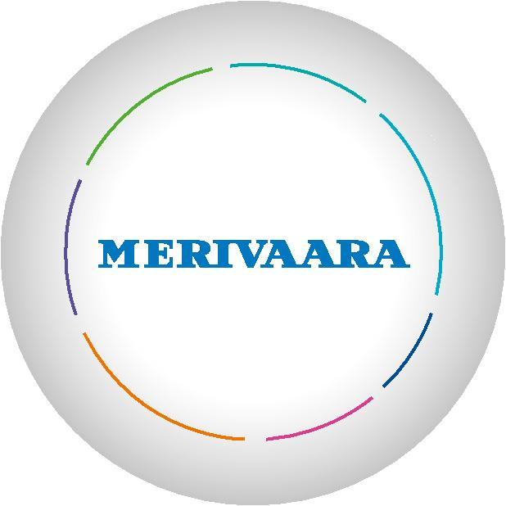
integrated management systems and after-sales services.

Our versatile solutions and product offering enable convenient and cost-effective physical patient flow within the hospital, in day surgery and health clinics, as well as in nursing homes and home care. Our priority is to enhance comfort and well-being of both patients and their caregivers.

Established in 1901, Merivaara has more than 100 years of experience in designing and manufacturing hospital-grade furniture. Today our products are highly appreciated by users in more than 120 countries thanks to their ease-of-use, durability and ergonomic design.

 |  |  |  |  | d
 |  |  |  |  | r
 |  |  |  | a
 |  |  |  | W
 |  |  |  | t
 |  |  | n
 |  | e
 |  | i
 | t
P | a
e r a C e

m o
H
R
E
D a y S u r g e r y
O
p
e
 | r
 | a
 |  | t
 |  |  |  | i
 |  |  |  | n
 |  |  |  | g
 |  |  |  |  | R
 |  |  |  |  | o
 |  |  |  |  | o
 |  |  |  |  | m
 |  |  |  |  | S
 |  |  |  | e
 | i |  | v | r
c
e
M
a
r e t

Merivaara’s medical products are CE-labelled and the company’s quality management system complies with EU directives for medical device. It is certified by DNV according

to ISO 9001:2008 and ISO 13485:2003 standards. The company’s environmental management system is ISO 14001:2004 certified.
y t i n

Merivaara Corp.

Puustellintie 2, FI-15150 Lahti, FINLAND Tel. +358 3 3394 611, fax +358 3 3394 6144 merivaara@merivaara.com www.merivaara.com

The status of the information, specifications and illustrations in this publication is indicated by the date of publication. Whilst the greatest care has been taken over its compilation, Merivaara Corp.is not responsible for any errors or omissions. Merivaara Corp. reserves the right to make changes to the technology, features, specifications and design of the equipment and models without notice. Please check the Merivaara website for the latest updated specifications and other information.

All trademarks are Merivaara property unless otherwise stated. Patents granted or pending.

©Merivaara Corp. 6007EN 112012, printed in markprint

